1. Identify which categories are popular in each seasons?

Ans:The table provided categorizes the number of customer purchases for various product categories across four seasons (Fall, Spring, Summer, Winter). The question is to identify which product categories are popular in each season. Here's a breakdown of the calculation process:

Identify Categories and Seasons: The rows represent product categories (e.g., Accessories, Clothing), and the columns represent seasons (Fall, Spring, Summer, Winter) Count Data: Each cell under a season shows the number of customer IDs (purchases) for a specific product (purchases) for a specific product category in that season. For example: Accessories in Fall: 324 purchases.Clothing in Spring: 454 purchases.

Grand Totals:

Row Totals: Sum the number of purchases for each category across all seasons (e.g., Accessories total = 324 + 301 + 312 + 302 = 1239). Column Totals: Sum the number of purchases for all categories within a season (e.g., Fall total = 324 + 427 + 136 + 0 + 88 = 975).

Seasonal Popularity: For each season, identify the category with the highest number of purchases. For example:Fall: Clothing (427 purchases).Spring: Clothing (454 purchases).Summer: Clothing (408 purchases).Winter: Clothing (448 purchases).

Overall Popularity:

Clothing is the most purchased category overall (1,737 purchases across all seasons).The calculations are straightforward summations of the rows and columns in the table 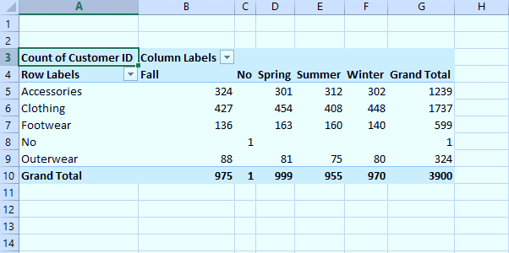

2. How shipping method influence customer satisfaction?

The table appears to be a pivot table summarizing the average review ratings for various shipping methods (e.g., 2-Day Shipping, Express, Free Shipping, etc.). Here's the calculation process for the pivot table:

Rows: Represent individual or grouped items (e.g., customer categories, product categories, or transaction IDs).Columns: Represent shipping methods. The row grand total averages the review ratings across all shipping methods for a particular group.The column grand total averages the ratings for a specific shipping method across all rows.

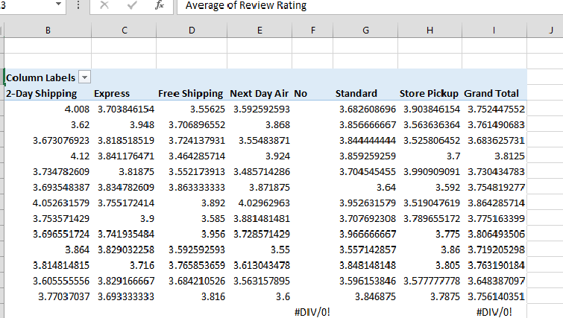

3. Which payment method preferance by category?

The provided table is a pivot table summarizing the count of customer IDs based on payment methods (row labels) and product categories (column labels). Here's the calculation process:

1. Data Source:The original dataset likely includes individual transactions with fields such as payment method, product category, and customer ID.

2. Row Labels:Payment methods (e.g., Bank Transfer, Cash, Credit Card, etc.) are grouped as row labels

3. Column Labels:Product categories (e.g., Accessories, Clothing, Footwear, etc.) are used as column labels.

4. Values (Count of Customer ID):For each combination of a payment method and product category, the pivot table calculates the number of unique customer IDs (or total transactions, depending on the data).

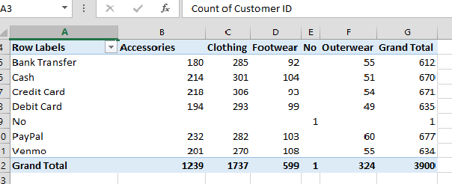

4. Identify how purchage frequency varies by gender and age group?

To understand and describe the calculation from the table you've provided, I will break it down into its pivot table structure, focusing on its rows, columns, and data:

Key Observations:

Row Labels:

Represents categories or grouping levels (e.g., "Annually," "Bi-Weekly," "Monthly," etc.).The row labels describe time intervals (payment frequencies, survey intervals, or reporting schedules).

Data Columns:

Each column after the "Row Labels" appears to represent data values (counts or measures). Specific intervals (e.g., "Weekly, Monthly") are associated with numerical values for various groupings.

Grand Total :A summary row at the bottom aggregates the data across all rows for each category.

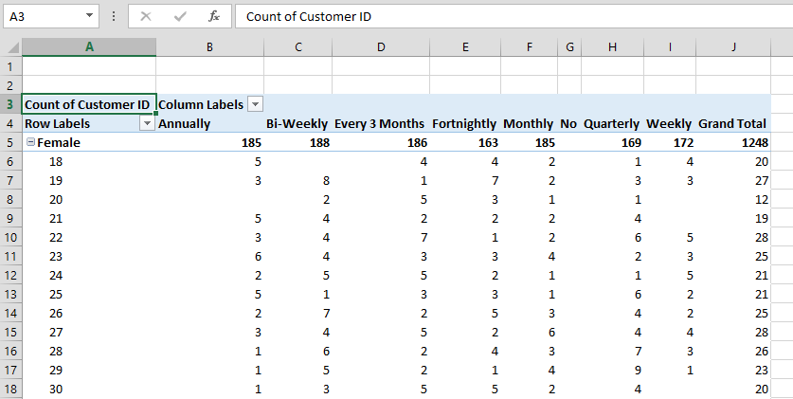

5. Identify the review rating by discount?

The provided data seems to reflect a PivotTable summarizing review ratings based on specific categories. Here's an explanation of how the calculations work within the table:

Components in the PivotTable

Row Labels (Column A): Represent distinct categories for a variable, e.g., "No" and "Yes."

Column Labels (Column B): Reflect categories for another variable or a binary condition.

Values (Columns C and D): Display the calculated average of the review ratings for each combination of row and column labels.

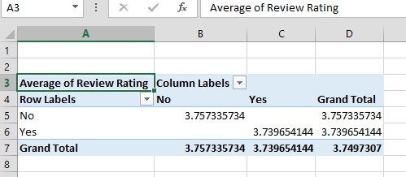

6. What is the most popular colours in each season?

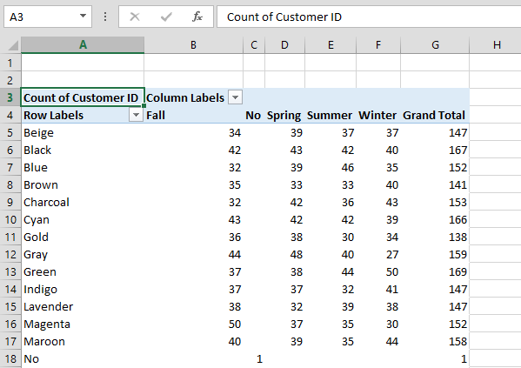

Calculation process

Row Labels (Column A): These represent different colors (e.g., Beige, Black, Blue, etc.).

Column Labels (Columns C-F): These represent seasons (Fall, Spring, Summer, Winter).

Values (Columns C-G):

Each cell shows the count of customers who selected a particular color during a specific season.

The "Grand Total" (Column G) sums the counts for each color across all seasons.

7 .Which sizes prefers to purchase by gender?

Table:

Row Labels (Column A):

Represent different sizes (L, M, S, XL, No).

Column Labels (Columns B-D):

Represent gender categories:

Female (Column B)

Male (Column C)

No (Column D) (possibly for unknown gender or no preference).

Values (Columns B-E):

Each cell shows the count of customer IDs that match a specific size (Row Label) and gender (Column Label).

Grand Total (Column E and Row 10):

Column E: The total count of customer IDs for each size across all genders.

Row 10: The total count of customer IDs for each gender across all sizes.

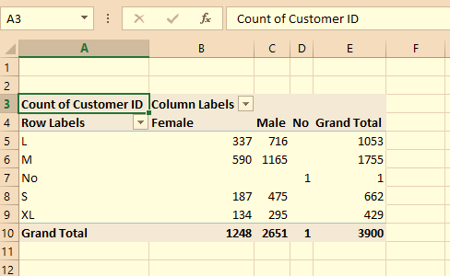

8 .How the age influence on review rating?

The table provided appears to summarize data using a pivot table.Row Labels represent the grouping or categorization of data.Average of Review Rating represents the mean value of review ratings for each group in the row labels.

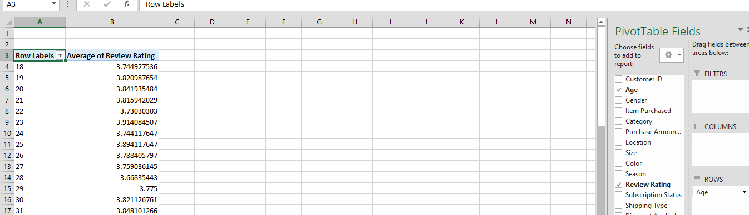

9. Which is the most used shipping method?

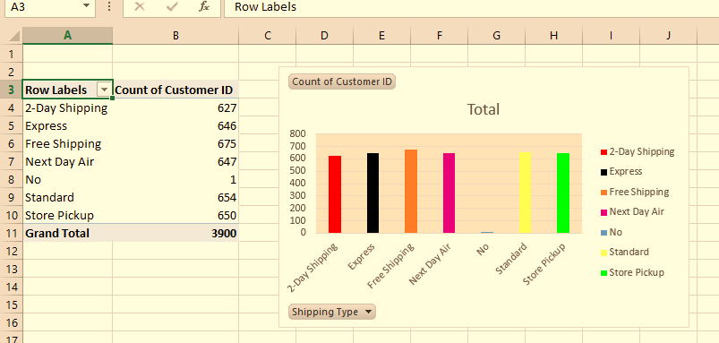

The calculation described in the pivot table represents a summary of shipping methods and their respective counts of "Customer ID" entries. Here is the breakdown of what the pivot table represents:Row Labels: These are the different shipping methods available, such as "2-Day Shipping," "Express," "Free Shipping," etc. Each label represents a category of shipping option.

Count of Customer ID: This column provides the total number of "Customer ID" entries associated with each shipping method. It reflects how many customers

Grand Total: The sum of all counts in the "Count of Customer ID" column, which in this case is 3,900. It represents the total number of shipping method choices made across all customers.

10. Identify discount uses trends across seasons?

This pivot table categorizes and summarizes customer data based on two dimensions: seasons (Fall, Spring, Summer, Winter) and whether a particular condition (labeled as "Yes" or "No") was met. The calculation represents a count of Customer IDs within each category. Here's how it works:

Row Labels: These represent the seasons (Fall, Spring, Summer, Winter). Each season is a category summarizing customer data.

Column Labels: These represent the two conditions, "No" and "Yes", indicating whether customers did or did not meet the specified condition.

Count of Customer ID: The counts represent the number of customers for each combination of season and condition

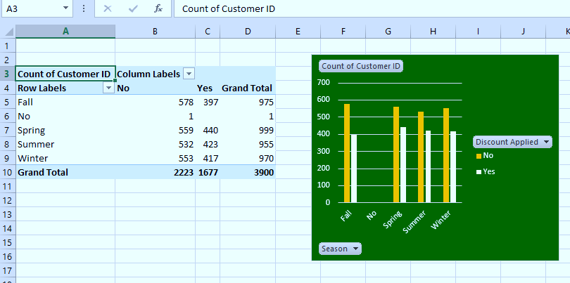

11. Which gender prefers using discount?

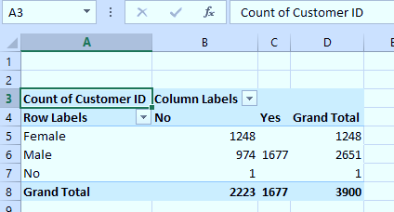

This pivot table categorizes and summarizes customer data based on two dimensions: seasons (Fall, Spring, Summer, Winter) and whether a particular condition (labeled as "Yes" or "No") was met. The calculation represents a count of Customer IDs within each category. Here's how it works:

Row Labels: These represent the seasons (Fall, Spring, Summer, Winter). Each season is a category summarizing customer data.

Column Labels: These represent the two conditions, "No" and "Yes", indicating whether customers did or did not meet the specified condition.

Count of Customer ID: The counts represent the number of customers for each combination of season and condition

12. How payment methods vary by location?

The pivot table presents the count of Customer IDs categorized by states (row labels) and payment methods (column labels). Here's a breakdown of how the calculation works according to the pivot table:

Row Labels (States):The rows represent different states (e.g., Alabama, Alaska, Arizona, etc.).

The counts in the rows reflect the number of customer IDs associated with each state.

Column Labels (Payment Methods):The columns represent different payment methods (e.g., Bank Transfer, Cash, Credit Card, etc.).Each cell in the table corresponds to the count of customer IDs using a specific payment method in a specific state.

Grand Totals:Row grand totals (at the end of each row) sum up the counts for all payment methods within a specific state.Column grand totals (at the bottom of each column) sum up the counts for all states using a specific payment method.

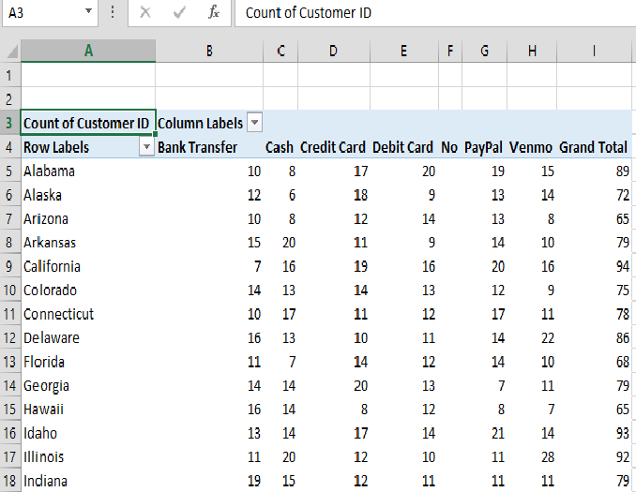

13. What is the average review rating by size and season?

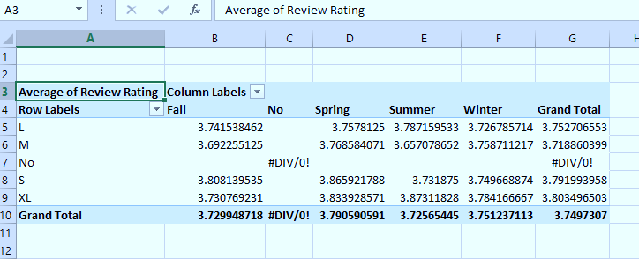

The provided data appears to represent a Pivot Table that calculates the average review ratings of some products, services, or categories across various conditions. Here's how the calculations are structured based on data:

Key Components of the Pivot Table:

Row Labels: These represent the main categories being analyzed, such as "5L," "6M," "7 No," and "9 XL."These could indicate product sizes, user groups, or other classification type.

Column Labels: These represent the time periods or seasonal categories ("Fall," "Winter," etc.), plus an overall "Grand Total."The values under each column show the average review rating for that row and time period.

Values: The main data calculated is the average review rating for each combination of row and column labels.

14 .How do purchase frequencies compare between genders?

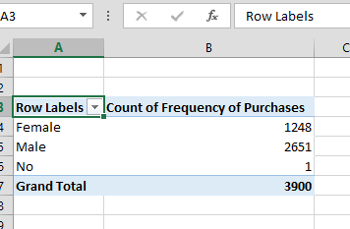

**Row Labels:**

These represent the demographic groups being analyzed:Female: Indicates the purchases made by female customers.Male: Indicates the purchases made by male customers.No: Likely represents cases where gender information was not provided. This might be an outlier or special category requiring clarification.

**Values:**

The value in each row represents the count of purchases for the respective demographic category.